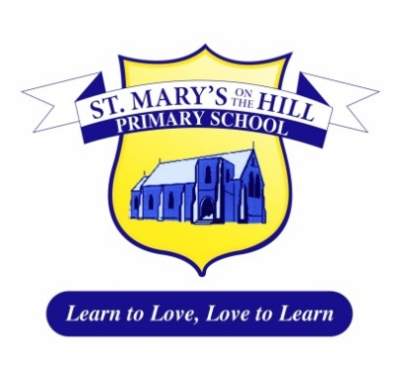

Dear Parents/Carers

**Free School Meals**

The application process for free school meals/uniform has commenced. Parents who are currently eligible to apply for free meals/uniform should now complete their application. **Please note that entitlement to free school meals will attract funding to the school’s budget**. Whether your child wishes to partake of a meal or not is down to individual choice. We would really encourage parents who fall into this category to please make an application as soon as possible for the incoming academic year. Application forms may be obtained via the Education Authority website – [www.eani.org.uk](http://www.eani.org.uk) or alternatively by contacting Free School Meals Section on 028 2566 1355.  Forms are also available from the school.  Should you have any further queries regarding this, please contact the school office.  See attached leaflet from the Education Authority.

**School Uniform**

Thank you to all parents and carers, the children are all looking very smart in their new school uniforms.  **Can I remind parents that black trainers/trainers of any kind are not part of the school uniform and should not be worn to school**.

**PE Uniform**

I am aware children like to wear branded clothing such as Nike and Adidas however, these are not part of the school PE uniform.  Can I please ask that you ensure your child has plain navy shorts/navy tracksuit bottoms and a plain white polo top. The PE uniform should be worn on PE days.

**After School Clubs**

Children attending after-school clubs should wear their school uniform.  Prior to clubs starting children will be able to change in designated areas of the school.

Thank you for your continued support.

Yours sincerely



_________________  
Mr Ciarán Conway

(Principal)