

St. Mary's on the Hill September's Information 2026
Welcome to September at St. Mary's on the Hill
Dear Parents/Carers
A very warm welcome to a new school year at St. Mary's on the Hill Primary School. September always brings a special sense of excitement and possibility as our classrooms come alive once again with eager learners, familiar faces and new beginnings.
Over the past few days, it has been wonderful to see our pupils return with smiles, enthusiasm and a real sense of pride as they settle into their new classes. Whether joining us for the first time in Primary 1, moving into a new year group, or returning for their final year at St. Mary's, each child is embarking on an important stage of their learning journey.
September is also a time of reconnection. Friendships are renewed, new relationships begin to flourish, and our school community comes together once more after the summer break. While many children settle quickly, we understand that transitions can bring mixed emotions. Some pupils may feel nervous, uncertain or require a little extra time and encouragement. Please be assured that our staff are committed to ensuring every child feels safe, valued, supported and ready to learn.
As a school family, we remain committed to our mission of helping each child to "Learn to Love and Love to Learn." We want every pupil to experience success, develop confidence, grow in faith and character, and discover the joy that comes from learning alongside others. Throughout this year, we will continue to provide rich learning experiences that nurture the academic, social, emotional and spiritual development of every child.
This Sway will keep you informed about the many exciting activities, achievements and opportunities taking place across our school. We hope it gives you a glimpse into the wonderful learning that happens each day and celebrates the talents, efforts and successes of our pupils and staff.
Thank you for your continued support, encouragement and partnership. Together, we can ensure that this is a happy, successful and memorable year for every child.
If at any stage your child is finding the transition back to school difficult, or if there is anything we can do to support your family, please do not hesitate to get in touch. We are always here to listen and help.
As always, you can contact us via email at info@stmarys.newtownabbey.ni.sch.uk.
Warmest regards,
Matthew O'Brien
Principal
St. Mary's on the Hill Primary School
"Learn to Love and Love to Learn" 💙💛

Attendance - Let's aim Higher in 2026

At St. Mary’s on the Hill P.S., we believe that every school day counts. Last year, our overall attendance rate was 92%, which is lower than in previous year, this year, we’re aiming to ensure this increases.
📚 Attendance Matters – Let’s Aim Higher Together!
Regular attendance is vital for your child’s learning, social development, and overall wellbeing. When children are in school consistently, they build stronger relationships, develop better routines, and make steady progress in their education.
🎯 Our Goal for This Year
We are encouraging all families to help us increase our attendance rate and ensure that every child has the best opportunity to succeed. Even small improvements can make a big difference!
🚫 A Reminder About Holidays
We understand the importance of family time, but we must strongly remind all parents and guardians that holidays should not be booked during term time. Absences for holidays during the school year can disrupt learning and make it harder for children to catch up with their peers.
If you are unsure about term dates or need support with planning, please contact the school office—we’re happy to help.
🤝 Working Together
We appreciate the support you give your children in getting to school on time and ready to learn. If your child is experiencing any difficulties that may affect their attendance, please reach out to us. We are here to support every family and ensure every child feels safe, happy, and motivated to come to school each day.
📧 Contact us anytime at: info@stmarys.newtownabbey.ni.sch.uk

The Importance of Our School Uniform
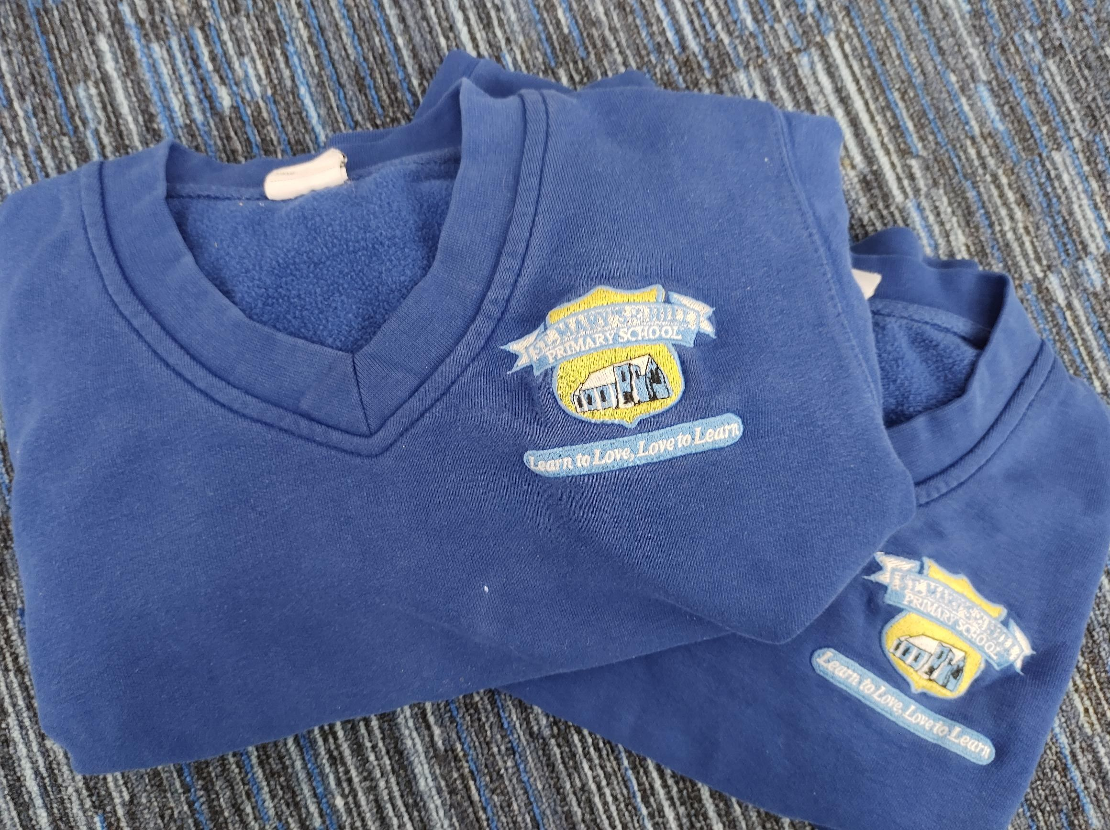
👔 The Importance of Our School Uniform
At St. Mary’s on the Hill P.S., our school uniform is much more than just clothing—it’s a symbol of pride, unity, and belonging.
When children wear their uniform, they represent our school community with respect and confidence. It helps create a sense of equality among pupils, reduces distractions, and encourages a focused learning environment. Most importantly, it fosters a shared identity and reminds us all that we are part of something special.
🌟 Wearing Our Uniform with Pride
We are proud of how smart and well-presented our pupils look each day. Thank you to all families for your continued support in maintaining high standards. A neat and tidy uniform reflects the values we hold as a school and helps children feel ready to learn.
👞 A Reminder About Footwear
As part of our uniform policy, we kindly remind all families that black shoes should be worn to school. Trainers or coloured footwear are not part of our uniform and should be reserved for PE days only.
If you have any questions about uniform guidelines or need support, please don’t hesitate to contact us.
📧 info@stmarys.newtownabbey.ni.sch.uk
Let’s continue to wear our uniform with pride and show the world what it means to be part of St. Mary’s on the Hill.
PLEASE LABEL ALL ITEMS OF CLOTHING

Car Parking

CHURCH CAR PARK: I would like to gently remind everyone of the difficulties and dangers around drop-off and collection of your child/ren. I am asking that all parents exercise extreme caution. To alleviate the difficulty of congestion we are asking all parents to make a LEFT TURN when exiting the car park. Please use the designated parking spaces or drop off zone.

WAITING AT THE GATE: Thank you all for your support and cooperation in the mornings whilst leaving your children to school. We would ask parents not to wait at the gate once they have left their child to school. By leaving your child off and moving off-site you are freeing up limited parking spaces. It can be difficult for children to enter through the gate when parents are gathered there. As the gate is in close proximity to the entrance of the car park we want to make every effort to ensure that no accidents occur. We would appreciate your cooperation in this matter as the safety of our children is our primary concern. Please pass this information on to anyone who will be responsible for leaving or collecting your child.

After School Clubs
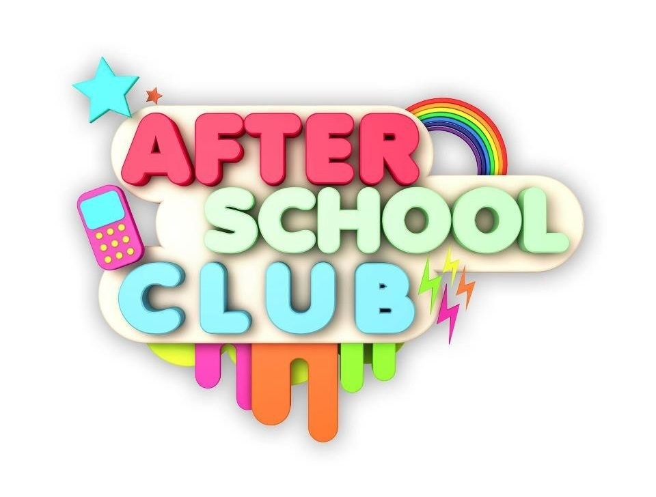
After School Clubs will commence week beginning Monday 7th September 2025. You can enrol your child and pay for the after school activity of your choice, through the Kidz Academey website. Hurling and Gaelic football clubs can be booked through School Money. We will also be introducing new clubs led by staff member on a Wednesday. Look out for communication on these over the coming weeks. These can again be paid for through School Money.

Waiting Club

The Waiting Club operates from 2pm—3pm Monday - Thursday. It costs £2.00 per day per child and is available for P1—P2 pupils. Payment for the Waiting Club can be made through School Money Online.

Free School Meals

The application process for free school meals/uniform has commenced. Parents who are currently eligible to apply for free meals/uniform should now complete their application. Please note that entitlement to free school meals will attract funding to the school’s budget. Whether your child wishes to partake of a meal or not is down to individual choice. We would really encourage parents who fall into this category to please make an application as soon as possible for the incoming academic year. Application forms may be obtained via the Education Authority website – www.eani.org.uk or alternatively by contacting Free School Meals Section on 02825661350. Forms are also available from the school. Should you have any further queries regarding this, please contact the school office.

Meet the Teacher

Meet the Teacher Sessions
One of the highlights of this term will be our Meet the Teacher sessions, which will take place during the week beginning 21st September.
These informal and welcoming sessions will provide an excellent opportunity for parents and carers to meet their child's teacher, put faces to names, and begin building the strong home-school partnership that helps children thrive. During the session, teachers will share key information about the year ahead, including learning priorities, classroom routines, expectations and some of the exciting experiences planned for the children over the coming months.
There will also be time to ask questions, gain a better understanding of how you can support learning at home, and connect with other parents and carers whose children are embarking on the same journey.
We recognise that a positive relationship between home and school is one of the most important factors in a child's success and wellbeing. These sessions are designed to help everyone feel informed, connected and confident as we begin another exciting year together at St. Mary's on the Hill.
Further details regarding dates and times for individual classes will be shared in the coming weeks. We look forward to welcoming you and working together throughout the year ahead. 😊
- P3 Monday 21st September

- P7 Tuesday 22nd September

- P2 Wednesday 23rd September

- P6 Thursday 24th September

- P4 Monday 28th September

- P1 Tuesday 29th September

- P5 Wednesday 29th September

Parent - School Communication Pathway

At St. Mary's on the Hill Primary School, we are committed to working in partnership with parents and carers. Open, respectful and timely communication helps us to support every child and ensures concerns are addressed as effectively as possible.

Step 1
Parent/Carer
Identify the nature of your query, concern or request for support.
If you are unsure who to contact, please contact the School Office who will direct you to the most appropriate member of staff.
⬇️

Step 2
Class Teacher
The Class Teacher should be the first point of contact for most matters relating to:
- Learning and progress
- Homework
- Friendships and social concerns
- Behaviour concerns
- Attendance queries
- General classroom matters
Many concerns can be resolved quickly through discussion with the Class Teacher.
⬇️

Step 3
Relevant School Leader
Where additional support or guidance is required, concerns may be referred to:
Foundation Stage
Mrs Brady
Key Stage 1
Mrs Thompson/Mrs Magee
Key Stage 2
Mrs Prendergast/Mrs McConvey
Special Educational Needs (SEN)
Mrs Thompson (SENCo)
Pastoral Care / Safeguarding
Mrs Magee/Child Protection Team
⬇️

Step 4
Vice Principal
Where concerns remain unresolved following discussions with the appropriate staff member.
⬇️

Step 5
Principal
Where further support, clarification or resolution is required.
⬇️

Outcome
Agreed Action / Resolution

Important Safeguarding Information
If a parent/carer has a concern relating to the safety or wellbeing of a child, this should be reported immediately to:
Mrs Magee or a member of the Child Protection Team

Our Communication Pathway
We are committed to open, respectful and timely communication. To help us respond effectively, we ask parents and carers to raise concerns through the following pathway:
Parent/Carer → Class Teacher → Relevant School Leader → Vice Principal → Principal
Our aim is always to work together to achieve a positive resolution that supports the best interests of every child.

Allergy Awareness
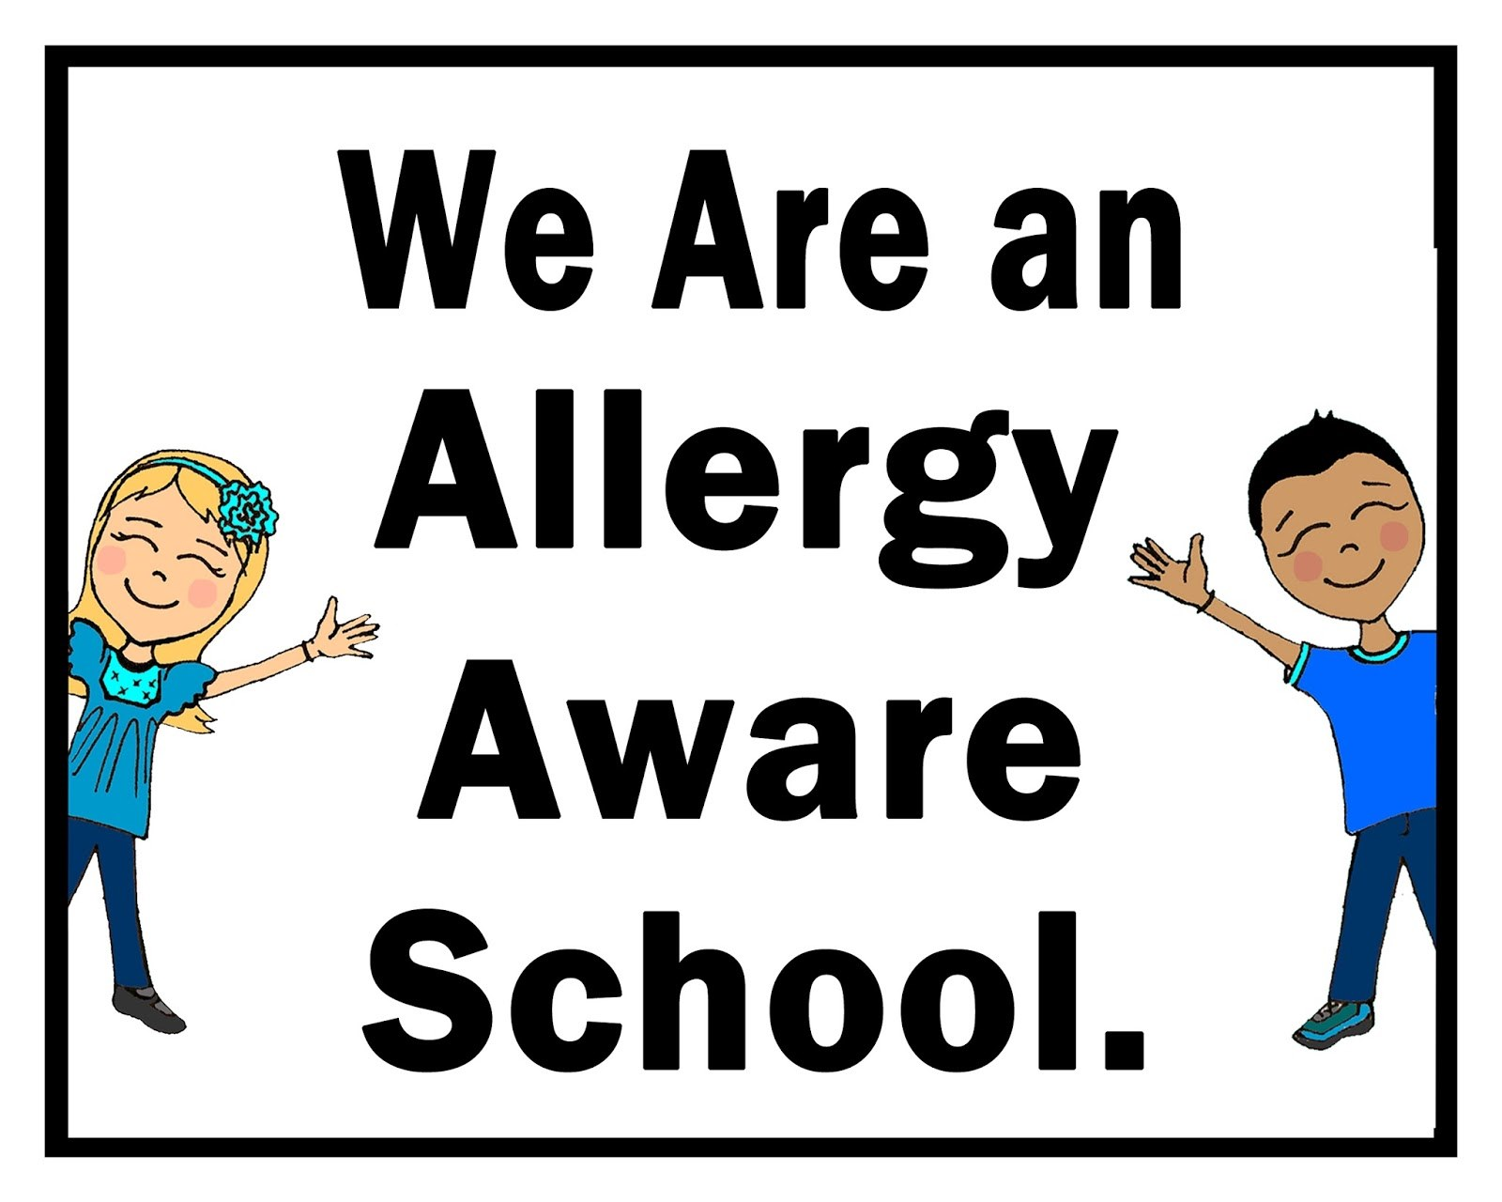
We have a number of children who suffer from allergies, which can result in potentially serious consequences. I would therefore ask that these children are not exposed to danger and that you are mindful of any children in your child's class who may have an allergy. We continue to be a Nut Free School and I would ask that you do not send in anything that would contain nuts.
Parents of children with diagnosed allergies are asked to provide the school with 2 Epipens (with valid dates) and any other necessary medication as soon as possible.
Please continue to support our ‘Healthy Eating Policy’ and provide your child with a piece of fruit and water or milk for break.

Administraion of Medicine

Please speak to your child’s teacher if you require medication administered to your child whilst at school. Parents need to sign and complete an ‘Administration of Medication’ form (available from the school office) before the school will administer the medicine. All medication needs to be prescribed, should have the child’s name on it and the dosage clearly labelled. Teachers will not administer medication that is not labelled as such. Please do not send in any medication with your child – it must be handed into the school office by an adult. Thank You.

School Dinners
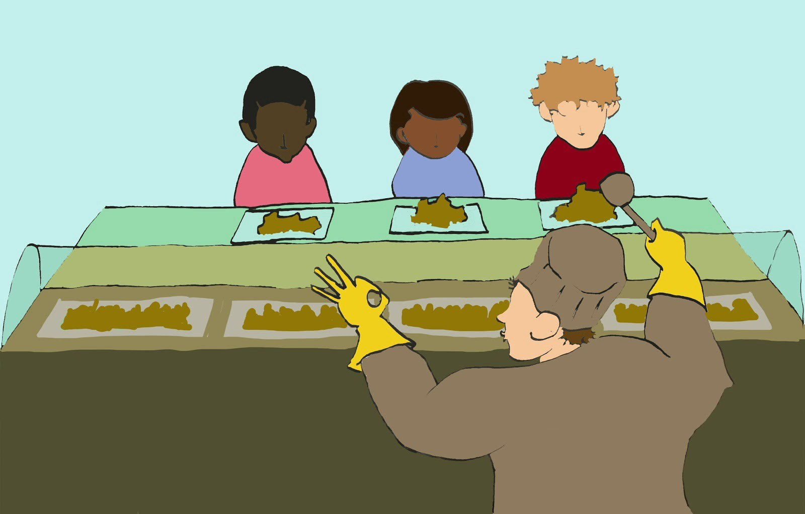


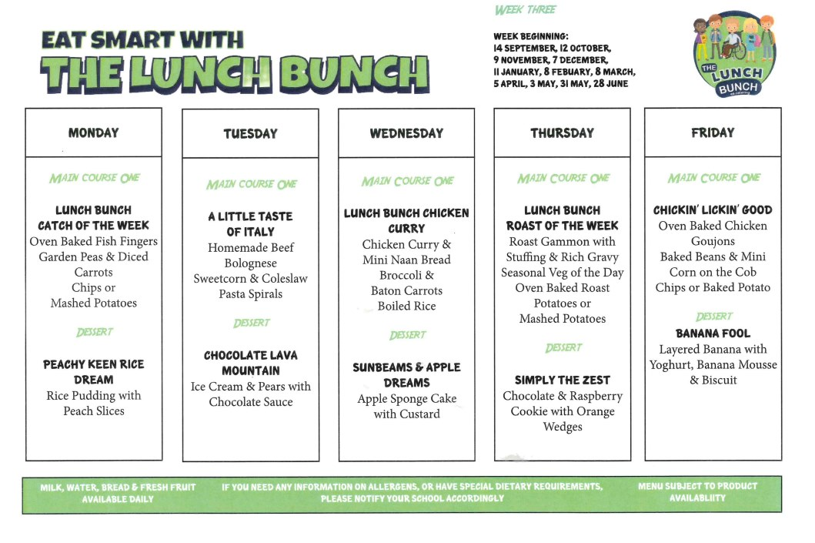
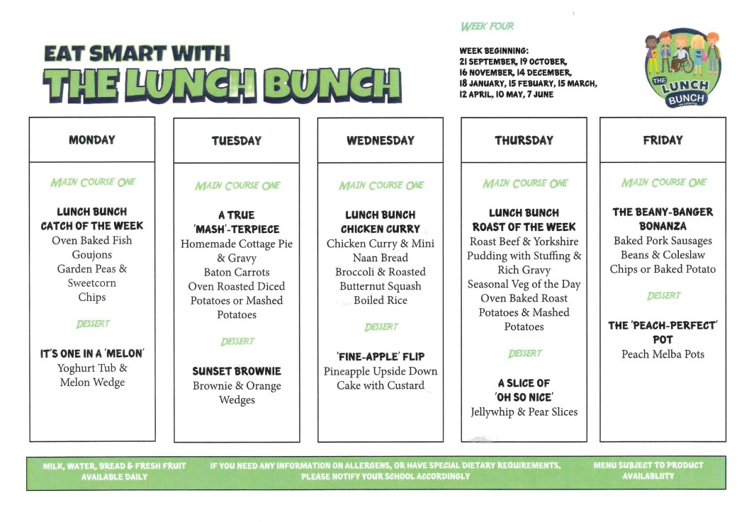

Back to school helplines from EA
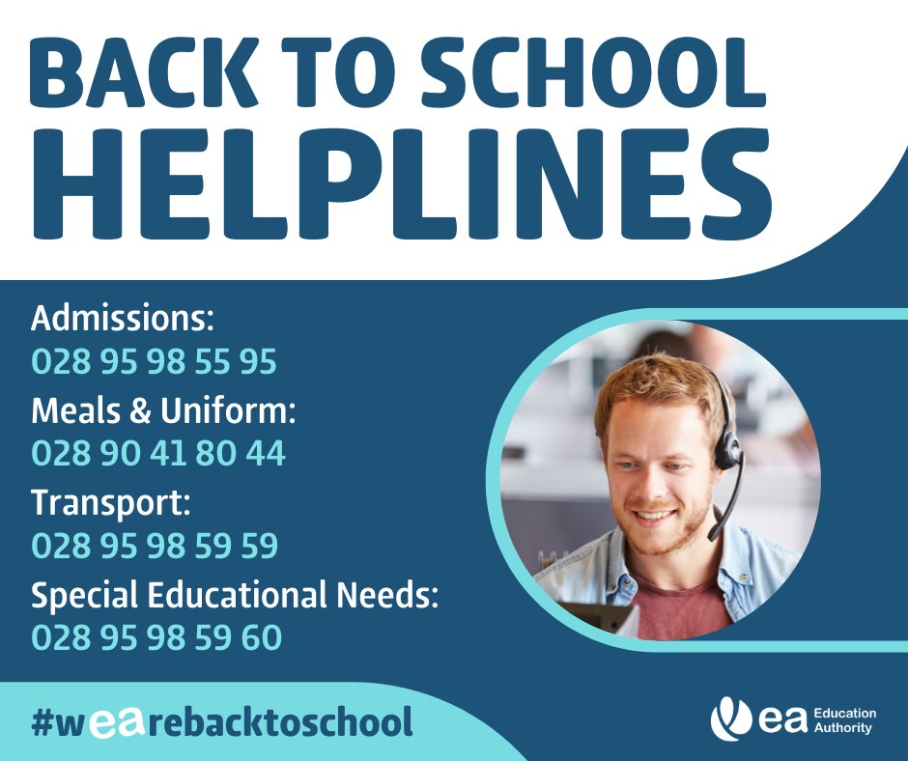
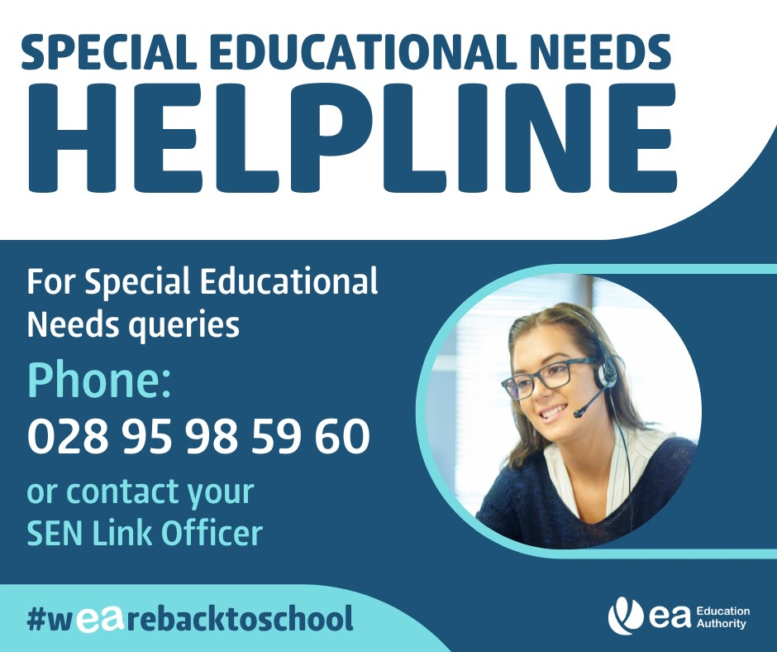

Lost Property

There are a number of items of lost property in the school. These items will be placed on a table in the Infant playground on Thursday 11th September and Friday 12th September from 1:30pm (Weather permitting - a new date will be issued if the weather is inclement). There is a range of coats, jumpers and other pieces of clothing that may belong to your child.

Dates for Diary

Monday 29th September - Staff Development Day (Children do not attend school)
Tuesday 7th October - P1 Parents Phonics workshop in assembly hall at 9:15am
Friday 28th November 2025 - Parent Teacher Interviews

Contact Details

If your address, telephone number or email address change please inform Mrs Mason in the office to ensure we have up to date information should we have a need to contact you.

